Home Solicitations

DO NOT BE AFRAID TO SAY, "NO!”
Be wary of salespersons that start their sales pitch by saying that they are "just taking a survey" or "trying to get rid of extra inventory."

Do not ever let a salesperson into your home unless you have seen proper identification and determined exactly what he or she wants.

No matter how attractive an offer appears, refrain from making an immediate purchase. It is wise to take a couple of days to consider the actual offer or deal presented.

DO NOT BE AFRAID TO SAY, "NO!”

Solicitors are required to have a solicitors permit from The City of Little Rock’s Finance Department and must be able to show it.
This is what the City’s for profit and non-profit Solicitors Permit look like. They are 4 inches by 5 ½ inches in diameter.

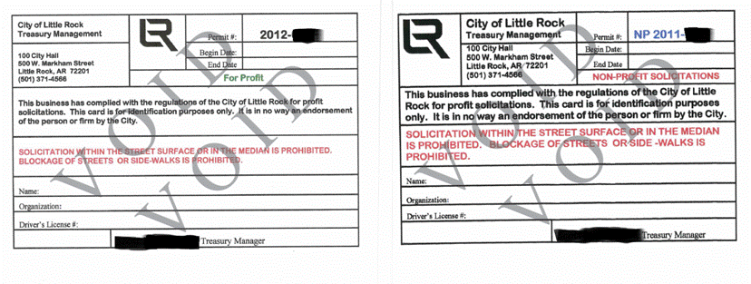

Alarm Companies are licensed and regulated by the State Police. Employees of an alarm company that monitor, install, service or survey must be registered with the State Police. They also must have a solicitors permit from the City of Little Rock Finance Department.

An alarm company cannot install a system on the same day. 72 hours must pass before installation; if not, charges can be brought against the company.

The registration card will have Arkansas State Seal, Card holder’s name, Company name and Photo of employee. On the back it will have State Police Contact information and the signature of the State Police Administrator.

DO NOT BE AFRAID TO SAY, "NO!”

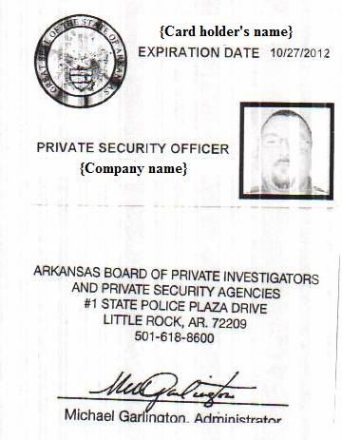

DO NOT BE AFRAID TO SAY, "NO!”

Arkansas Attorney General
Consumer Protection 501-682-2341

Dwight Davis
Public Affairs Coordinator
Neighborhood Watch Program Coordinator
Crime Prevention Specialist
Little Rock Police Department
(501) 918-5358

